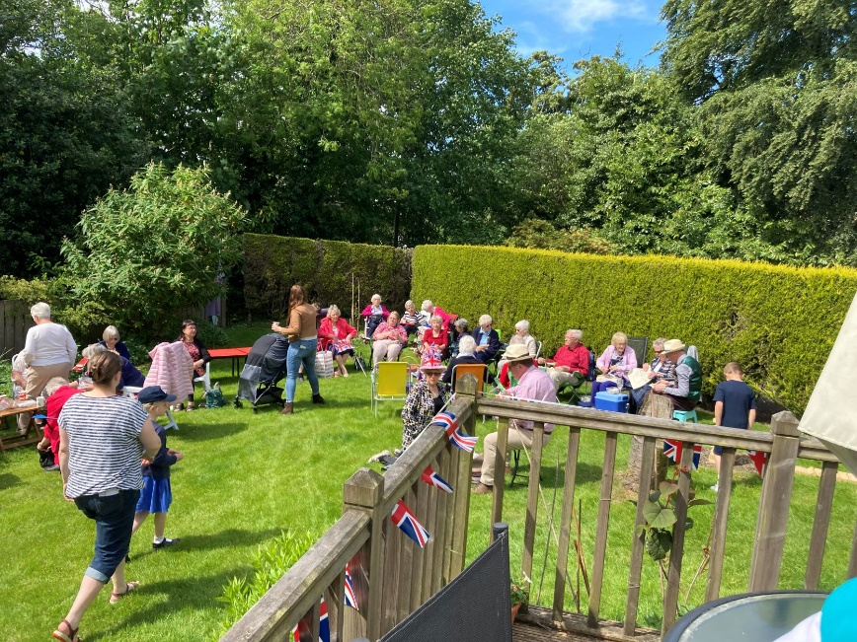
NK Wee Bulletin
9 June 2022

Platinum Picnic
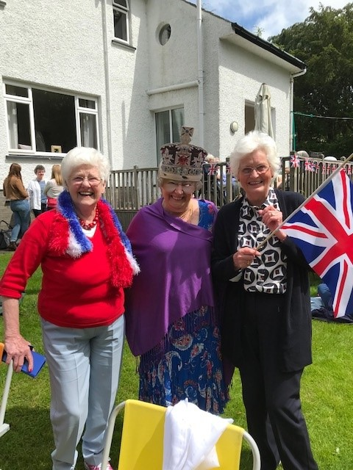
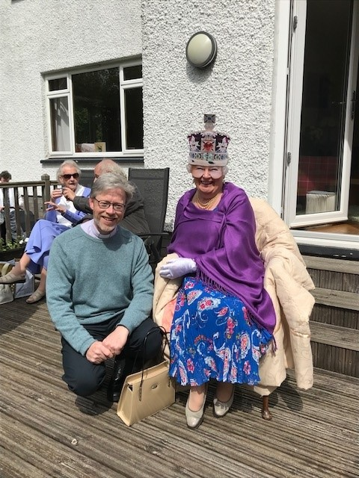
Some photos of our Platinum Picnic. Just wondering if the ‘Queen’ has a marmalade sandwich in that handbag.
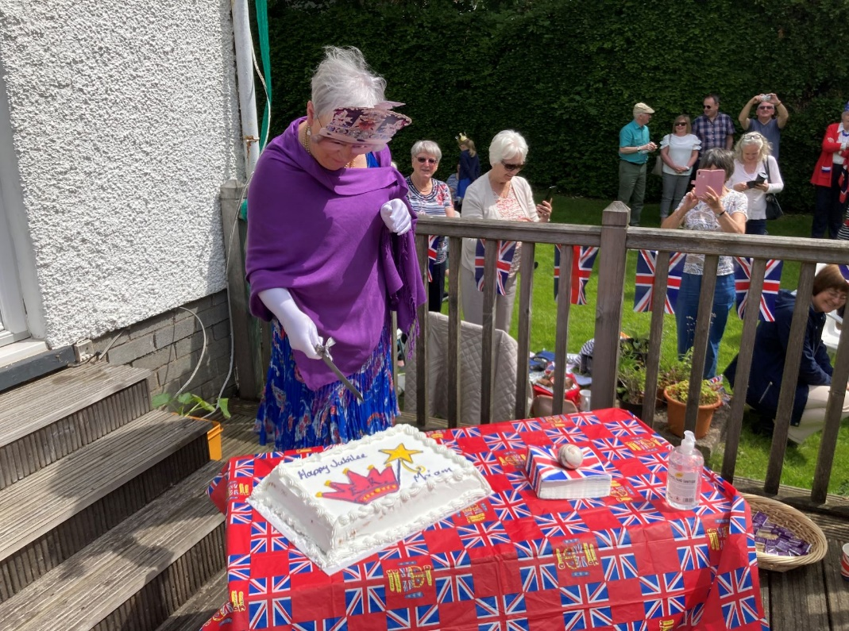

Food Bank Drop Off
We have been hearing a lot about the increasing need for food banks and how food banks we already have are running low on stock due to the increase in the cost of living.

We will all feel the effect but some far more than others. Helping with donations is something we have been involved in supporting for a number of years and have built good relationships with three food banks, which we have continued to support.

In response, we would like to set up a permanent drop-off area in the hall, keep contact with the three partner food banks we have supported regularly in the past, and work with them to gather the right food, household items and toiletries through the year.

Would you be interested in helping to organise this? We hope to set up a task group of 4 or 5 people to work together to organise, keep contact, find out what to collect, and ask for volunteers to deliver items to food banks as they are gathered. We would like to set up this small team from across the congregation within the next fortnight.

If you are willing this relationship-building project, please contact the office (mail@nkchurch.org.uk 0141 942 8827).

SingSong!
SingSong! is very happy to say that we are meeting again in the New Kilpatrick Church New Halls for two more meetings before the end of June. The next meeting is this Tuesday, 14th June, and then on 28th June, both at 1.30 – 3pm.

SingSong! is open to anyone who likes a singalong of popular songs with a bit of fun, but also welcomes those who have a degree of memory loss. And, of course, we round it off with a cup of tea and chat. More information from Kirsteen Maclean, 0141 942 7603 or kirsteen7@btinternet.com

Precautions will be taken to keep everyone safe and new and present members are very welcome.
Summer Services
We’re sharing our summer services this year, as we once did, with the Cross Church, beginning from June 26th.

Together we’ll be on our travels though sunnier weather, exotic destinations, and beautiful scenery from the story of Abraham. We begin the journey here in New Kilpatrick on 26th June for four weeks and then travel ourselves to the Cross church from 24th July to 14th August.

We offer both the 9.30 and 10.30 service all the way through the summer, with the 9.30 in the church hall for the first four weeks and then transported (no passports required) to the Cross Church Hall. And the 10.30 service in the church, a more classical version of worship, beginning in New Kilpatrick and moving to the Cross Church on the 24th.

We are still looking for three volunteers to help with hospitality between the 9.30 and 10.30 services for Sunday 26th June and Sunday 3rd July. If you are willing, please contact the church office (mail@nkchurch.org.uk, 0141 942 8827).

Mask Wearing
We invite people to continue to wear masks in church as you feel comfortable but there is no specific area for mask wearing.

People are spread about a bit more and doors continue to be open to enable good ventilation, and hand gel is available for use at the doors.

We hope everyone continues to feel comfortable and safe.

If mask wearers prefer a specific space, can we suggest that the far pews on the pulpit side tend to be for those wearing masks.

Coffee Pot
We hope to re-launch the Coffee Pot on Friday mornings after the summer.

Before we start, we need to talk about how we do this. If you would like to be part of a discussion group to work out a plan, please let Catherine know (0141 942 8827, mail@nkchurch.org.uk ).

It has always been a great way to keep in touch with each other and excellent for your figure with all the home baking. We would like to create that space again, where we can have our doors open for a time of friendship for everyone.

More details to come, if and when we get a group together.

Parish Communication
Over the last two years, NK has made a big effort to keep in touch with as many people as they could find would benefit from contact, especially under lockdown.

Now that contact is becoming easier and some people are again being visited face-to-face, we find that our expanded list has led to needing more people to keep contact with those who may welcome a voice at the end of the phone, or a friendly face popping in to see them.

If you would be able to make one or two 3 or 4-weekly visits or might be willing to phone two or three people regularly, could you please contact either Catherine in the office (0141 942 8827) or Kirsteen Maclean (0141 942 7603).

Sunday Coffee
It’s good to be getting together again after Sunday morning worship for coffee and fellowship. Thanks to all those who have already volunteered to let this happen, with a rota in place up to 17 July.

We will need a new rota when we return to services in the church on Sunday 21 August, following the four weeks of summer services at Bearsden Cross Church. If you would like to be on the rota, please let us know. It would be great to ring the changes and have some men volunteering too.

Hoping to hear from lots of folk ready to join our volunteers. 0141 942 8827, mail@nkchurch.org.uk

Diary

Thursday 9th
Daybreak in the church hall at 1.30pm
NK Heritage Group at 7.30pm in the church hall

Sunday 12th
Morning Worship led by Rev Jeanette Peel, 10.30 in the sanctuary. The Sunday School meet on the bean bags in front of the chancel, before going on to the hall.

Tuesday 14th
SingSong! At 1.30pm in the church hall

Wednesday 15th
Midweek Service, 11am in the hall, followed by coffee and cake

Thursday 16th
Daybreak in the church hall at 1.30pm

New Kilpatrick Parish Church of Scotland Minister: Rev Roddy Hamilton, 0141 942 0035, roddy.hamilton@churchofscotland.org.uk Scottish Charity Number SC012997
Copyright Licence Number CCL 54127

