

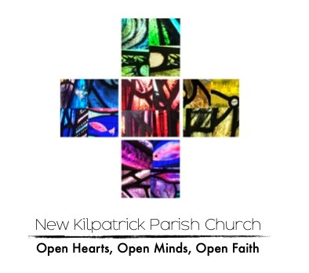

Rainbow Dreams
Wednesday 18th February 2026 9.30am to 11.30am
New Kilpatrick Church Halls

Cost: £2 for the first child and £1 for every child thereafter

Name/s of child/ren and age/s

Allergies

Any medical conditions we need to be aware of

Any additional support or needs required

Permission to take photographs for use on the church FaceBook page and Instagram Account YES/NO

Parents/Carers name and contact details inc mobile telephone number

If bringing an older sibling (due to the school holidays), please add their details above with the required information

New Kilpatrick Church requires personal information to ensure that we look after the well-being of all children & young people participating in activities as part of the church. All personal information (including sensitive data) is held in accordance with the General Data Protection Regulations (GDPR). Once the event is over their details will be deleted from our system.

