New Kilpatrick
Bulletin 16 April 2026

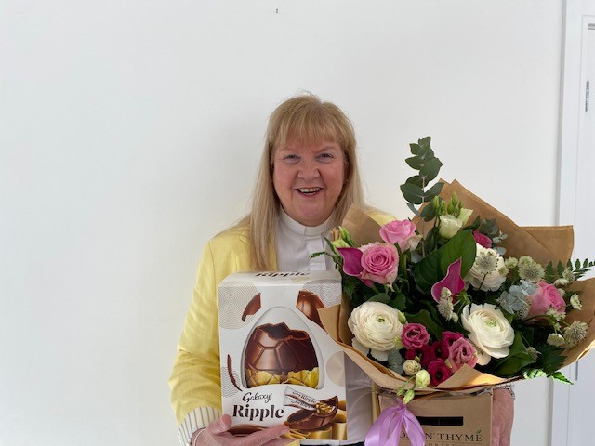
Barbara Ann
I would like to say thank you very much for the lovely sendoff you gave me on Easter Sunday.

The flowers were beautiful and the chocolate tasted great. What a lovely surprise it was to receive a monetary gift as well as vouchers, gifts and lots of cards. Thank you very much everyone.

I will miss you all, but I am sure you will see my face again at some of your events. Roddy might even give me some pulpit supply!!!

It was once again a privilege and a blessing to work alongside Roddy, and I am sure you all know what a gem you have.

Every blessing to you all.

Mosshead Fairtrade Thanks
Dear everyone,
Thank you so much for inviting us along to share our Fairtrade presentation at your Coffee Pot coffee morning. We really enjoyed being there with you all.
We are very grateful for the lovely warm welcome and the delicious home baking – it was very much appreciated! It was also great to have the chance to chat with so many of you afterwards.
A special thank you to Mrs Orrock for the Fairtrade chocolate gift. It was so kind and such a lovely surprise.
Thank you again for your kindness and hospitality. We had a wonderful time visiting.
Kind regards
Mosshead Fairtrade Committee


The 1% Club
How clever are you?
Come along to the hall on Friday 22 May at 7.30pm and find out!
No general knowledge is needed, just common sense and observation techniques.

Bring your own drink; nibbles will be supplied.
Tickets go on sale on Friday 24 April - £5 per contestant.

NK Ramblers The next walk is on Saturday, 18 April. Renfrew Circular, a
moderate walk. More information, including contact and meeting details, on the poster in the walkround.

NK Book Club Here are the dates and books over the next few months, all at 7pm in the hall:
28th Apr – Life and Limb by Jamie Andrew
26th May – Away with the Penguins by Hazel Prior
30th June – The Names by Florence Knapp
28th July – Theo of Golden by Allen Levie
25th August – Shy Creatures by Clare Chambers
29th September – The Fair Botanist by Sara Sheridan
27th October – The Five People you meet in Heaven by Mitch Albom.

St Gregory’s Food Bank
Thank you as always for the continuing support for SGFB. Please keep filling the trug in the hall walkround. The halls are open Monday – Friday, 9am – 2.30pm.

Eco-Congregation
Here is this bulletin’s EcoTip:
Try to skip the free travel size shampoos, soaps, and lotions offered by hotels. Bringing our own reusable travel sizes containers reduces waste.

If you have EcoTips we could share here, please email them to the church office.

Lost Property: From this Sunday, a table of lost property will be found in the church hall walkround and will remain there until Sunday 3 May, when any remaining items will go to a local charity shop.

NK Photography Project:
Everyone in the community is invited to picture ‘community’ in up to three photographs.

All entries will be displayed in the church hall from Friday 18th September to Sunday 20th September where visitors will be able to vote for their favourite adult and children’s categories.

The twelve most popular photographs will be made into a calendar and will be available to buy in November.

Maximum of three entries per person
Adult and Children’s Categories
(16 and under)

Please supply your contact details:
Name, Phone Number, and age if 16 or under.

Closing date 30th August 2026

Thank you for all the entries so far received. We look forward to receiving more over the year.

Glasgow City Mission:
Glasgow City Mission invites you to the “Light in the Darkness” conference — a time to reflect on the challenges facing people in Glasgow today and to hear stories of hope from those working at the heart of our city.

They will also look at how movements that began right here in Glasgow have gone on to shape missions across the globe.
Scan the QR code on the picture for full programme details and registration information.

The Mission is also looking for volunteers from
New Kilpatrick for next week’s Evening Drop-in. The dates to volunteer are Monday 20th April x 1, Tuesday 21st April x 1, both 6-8.30pm at Crimea Street.
There is a Sign-up sheet in the hall walkround.

Contact: Eileen Young on 07762 899127 or eileen.young3@icloud.com

‘Future Council’
Film Night at Cairns, Monday 20 April at 7.30pm. Following the successful screening of the film ‘2040’, which the Peace & Justice Group brought to Cairns in 2021, a follow-up film is to be screened on Monday 20 April at 7.30pm, again in Cairns Church.
In ‘Future Council’ Damon Gameau takes eight children from all over the world on the ultimate school excursion: a road trip across Europe to challenge powerful leaders and find solutions to our greatest ecological challenges. This is a coming-of-age journey that dares to imagine a brighter future”.
There will be no charge, but donations will be invited to cover the cost of hiring the film.

Holyrood Elections:
Pre-set questions on social justice issues such as poverty, addiction, immigration, net zero targets, health, and the environment etc will be put to the local Scottish Labour candidate. Details as follows:
16th April 7-8.30pm
James Adams (Scottish Labour) Immaculate Conception Church Hall,
2049 Maryhill Rd

The Calendula Quartet
present “Strings for SCIAF” in Maryhill Ruchill Church on Saturday 25th April at 7pm.

An evening of Delius, Haydn, Puccini and more. Entry by donation and all funds go to SCIAF. Refreshments will be served.

Solar Aid Safari Supper
Our next event to raise funds for Solar Aid is on Friday 15th May in the New Halls from 7pm until 8.30pm.

The event will take the form of a hot meal with 3 choices, including vegetarian, so something for everyone.

After the meal there will be a special video and powerpoint presentation about the current work of Solar Aid prepared by the Solar Aid Team in London especially for us. In addition there will be games; an opportunity to learn an African song (and possibly dance !) and a competition for children which is food related.

Tickets costing £10 per adult and £20 for a family will be on sale via the church office from Wednesday 22nd April.

PS Dressing up as an animal is encouraged (but not essential!).

The Diary
Thursday 16 April:
Daybreak 1.30pm in the hall.

Friday 17 April
Coffee Pot from 10am in the hall

Sunday 19 April
Morning Worship 10.30am
Words and Music 6.30pm in the hall
Monday 20 April:
The Monday Club 2pm in the hall

Tuesday 21 April:
Baby & Toddler Drop-in 9am – 12noon, hall

The Guild 2pm in the hall.
Film Afternoon: Downton Abbey

Up for Discussion: Bible Study
7.30pm in the hall (Luke 4:1-5)

Wednesday 22 April:
Baby & Toddler Drop-in 9am – 12noon, hall

Midweek Service 11am in the hall

Thursday 23 April:
Baby & Toddler Drop-in 9am – 12noon, hall

Daybreak 1.30pm in the hall

Friday 24 April:
Coffee Pot from 10am in the hall.

Sunday 26 April:
Holy Communion10.30am

Evening Service 6.30pm in the hall.

Thought for the Week
"It is the mark of an educated mind to be able to entertain a thought without accepting it."

Aristotle, Ancient Greek philosopher and polymath.

Tuesday 28 April:
Baby & Toddler Drop-in 9am – 12noon, hall

SingSong! 2pm in the hall.

NK Book Club 7pm in the hall.

Wednesday 29 April:
Baby & Toddler Drop-in 9am – 12noon, hall

Midweek Service 11am

Thursday 30 April:
Baby & Toddler Drop-in 9am – 12noon, hall

Daybreak 1.30pm in the hall.

NK Heritage Forum 7.30pm in the hall.

